Presentation Q&A to Dan:

1. Review Outline

**Self-Introduction (2 min)**

**Background Problem (3 min)**

**Coop Workflow (2 min)**

**\*\*Project Demo** (28 min)**

**Summary of current progress (3 min)**

**Next Steps (5 min)**

**Learnings (4 min)**

**How did the Coop go in general? (1.5 min)**

**Show Gratitude (1 min)**

**Q&A (10 min)**

Which sections do you think should be expanded or interpreted with more details?

Is there any part you feel would be more valuable for the dev team?

1. Target Audience

Given that most of the audience may not know the billing app before, it might be challenging to make them quickly follow.

The current strategy is to introduce the basic concepts in the background section. When we dive into technical details in the demo section, we will also provide more context for them to understand (see #3).

For example, we may need to clarify UPC, billing rules, how do they work, and why CLYNK cares about them.

Is there any part you would like us to highlight more on throughout this presentation? Tech details VS design thoughts VS business/CLYNK impact

1. Demo Strategy

The demo of user operations should be pre-recorded. We can also provide a live version for QA.

**Feature Presentation:**

The demo will be broken into:

* General Settings (user roles, auto-logout, route guard, etc)
* UPC
* To-Do List
* Billing
* Admin-level actions

Does this order align well with your thoughts? Separating functions will be easier for us to introduce, while we are trying to keep a cohesive story.

**For each feature:**

1. Show the new app page

2. Highlight how functions are added / modified compared to the old app

3. Explain why we made this change

4. Show the impact: how does this change contributes to the long-term goals of CLYNK

Would you suggest adding or rearranging any steps?

1. UI Presentation Feedback

Is there anything missing from our last UI review that should be addressed or improved in this presentation?

5. Next Steps (ignore)

We can also talk about how the future vision aligns with CLYNK’s expectations as this project is moving forward. There will be long-term benefits vs challenges.

6. Overall Presentation Impact

From your perspective, what would make this presentation more impactful for the audience?

7. Additional Thought

Is there any missing part that you would like to see or highlight?

Prev Coding Question:

Q0 – also to Elva:

If the start date / end date is today, will the rule be considered as active?

Q1:

UPC: when adding new UPCs, is the UPC info complete if missing 'lastScanDate' and 'totalScanUnit' fields?

Are all fields required?

Q2:

Company: when adding new companies, the duplication scenario is prevented by comparing the name, but we used to allow name duplication?

Q3:

Do we need to filter manufacturers with NO ACTIVE RULES?

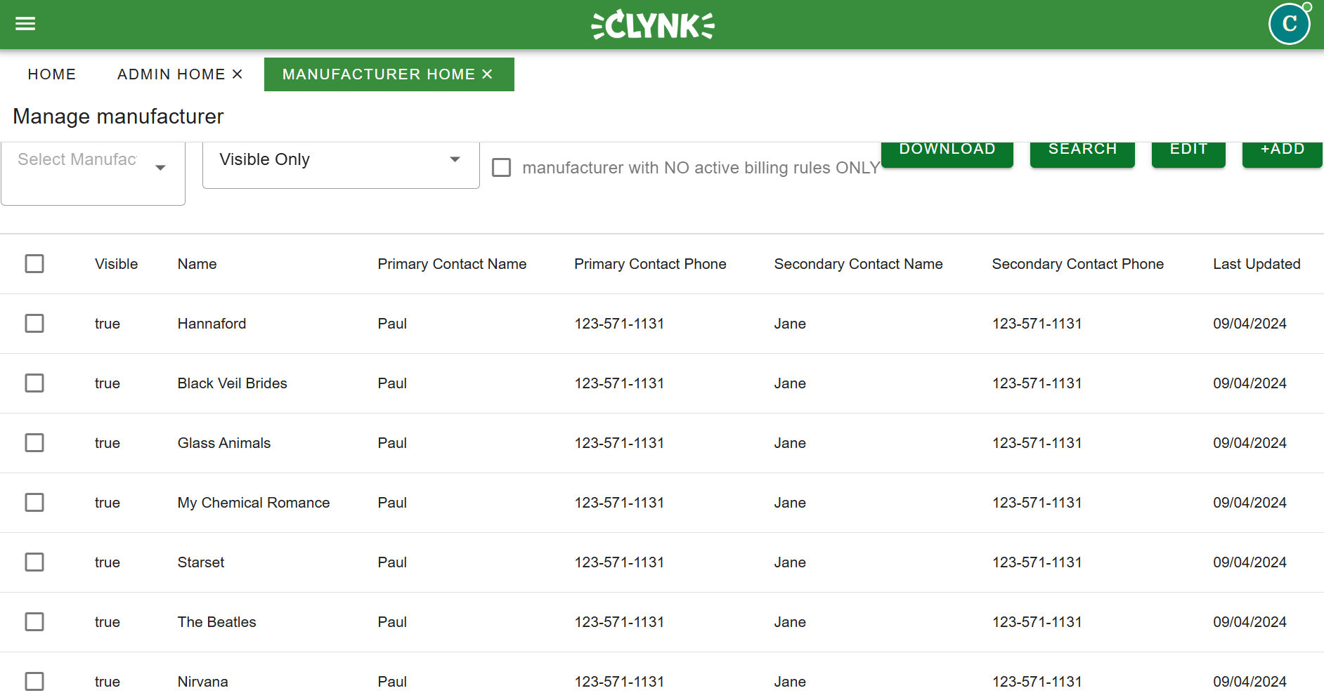

Q4:

1 primary + secondary list (new table)

Q5:

To-Do list: can the same UPC be added into the to-do list multiple times under different states?

Q6:

Currently we are assuming manufacturer, initiator, distributor, and pickup agents in separate database.

Is that a solid assumption?

Does Note also have an independent database? Y.

Next Thursday 1PM

Draft Dan +

1. Intern (exp)
2. App: here is the q we trying to solve so we did this way